**Answer 1 : A program, which reads height(feet.) of N students into a list and convert these heights to cm in a separate list:**

Code:

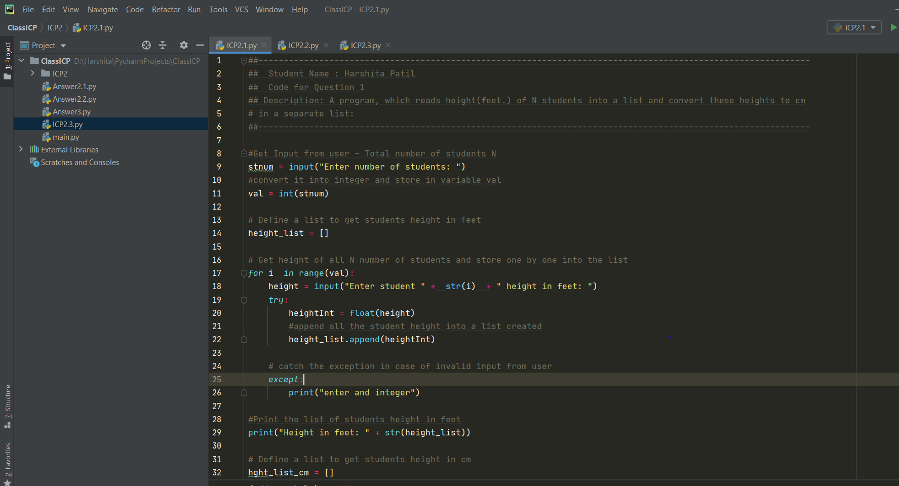

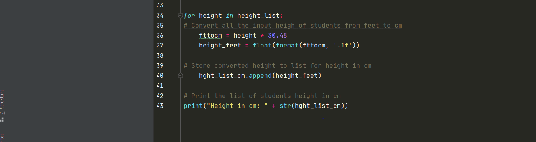

OUTPUT:

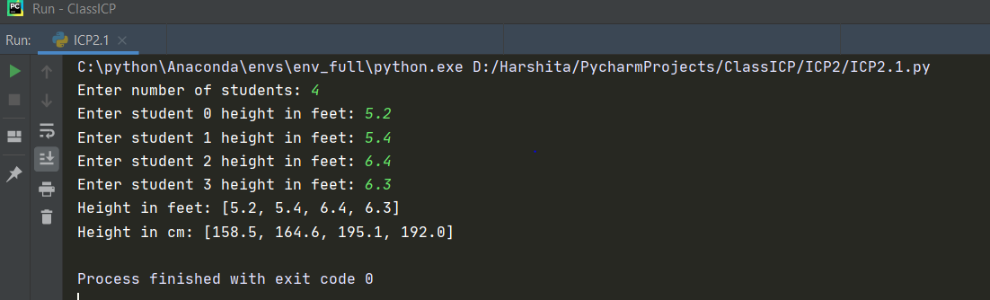

**Answer 2: This program with given a non-negative integer num, returns the number of steps to reduce it to zero. If the current number is even then it will divide it by 2, otherwise, it will subtract 1 from it.**

CODE:

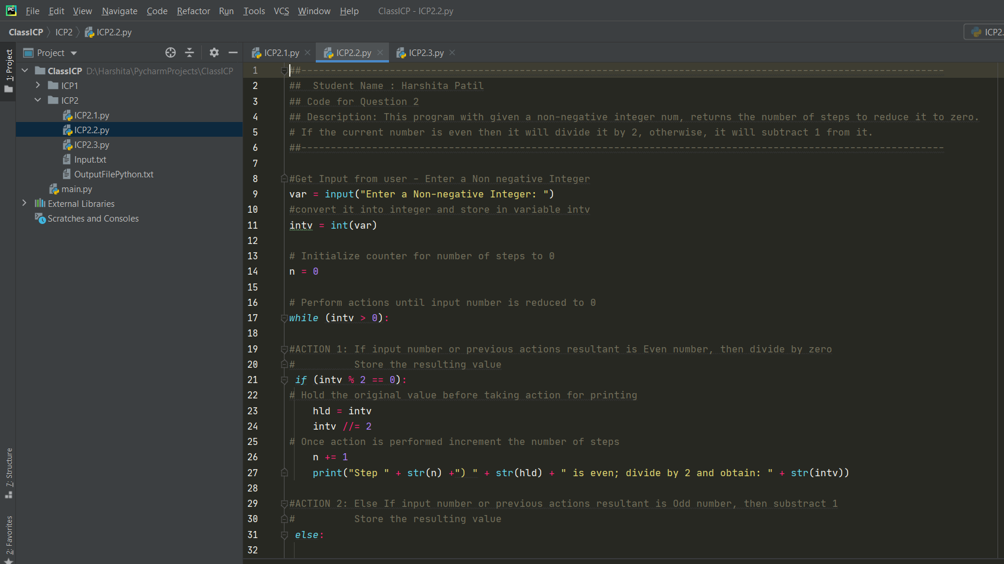

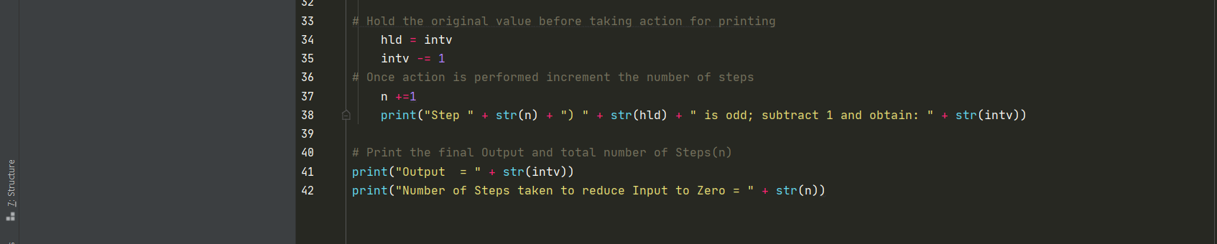

OUTPUT:

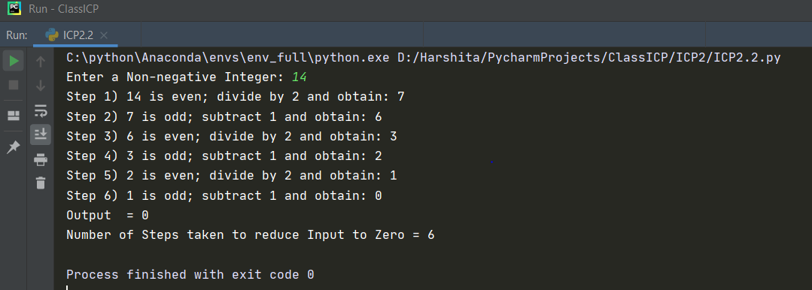

**Answer 3: A python program to find the wordcount in a file for each line and then print the output and then finally store the output back to the file.**

CODE:

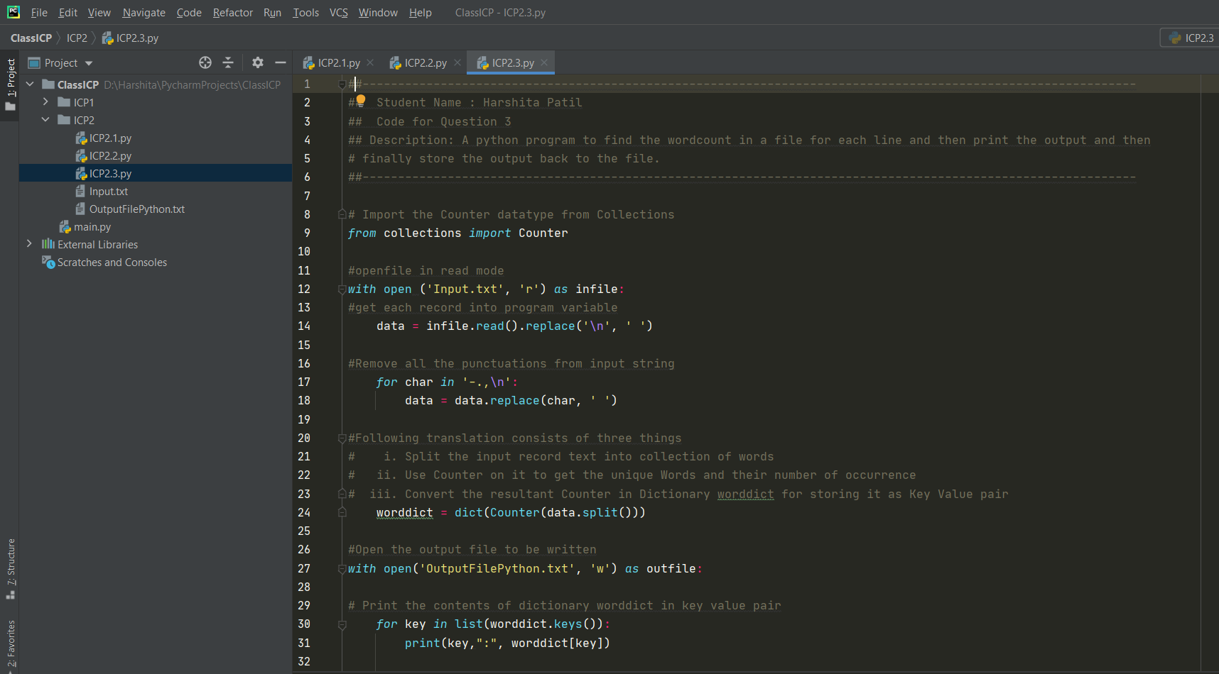

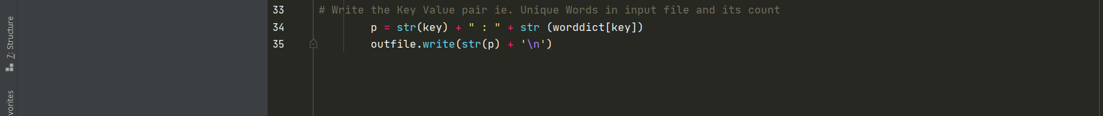

INPUT FILE:

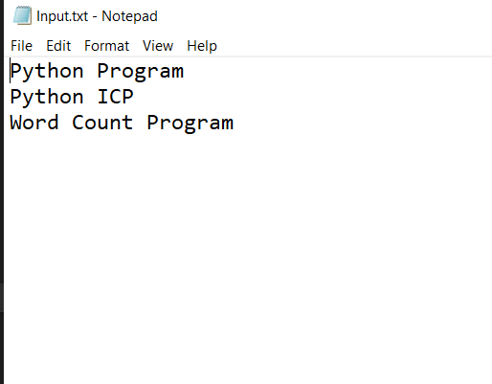

OUTPUT:

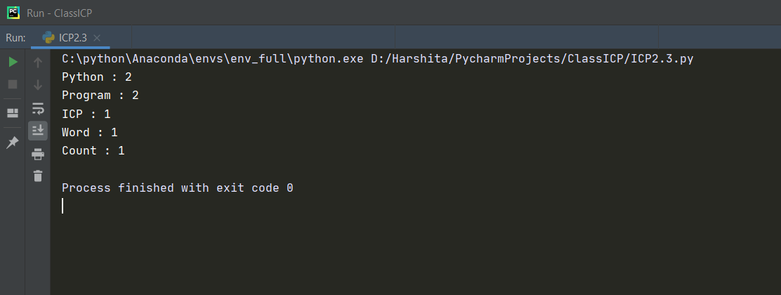

OUTPUT FILE:

